|  |  |
| --- | --- |
| outhern River College | **Year 11 Integrated Science**  **Task 8: Atomic Structure and Chemical Reactions** |

|  |  |  |
| --- | --- | --- |
| **Name:**  **Date:** | **Teacher:** | **Score: /46** |

**Multiple Choice Section**

**Question 1**

What is the scientific term that describes a combination of two or more substances?

**A.** mixture

**B.** solvent

**C.** infusion

**D.** sediment

**Question 2**

Which of the following describes a substance that **cannot** dissolve in a liquid?

**A.** filtrate

**B.** insoluble

**C.** residue

**D.** solute

**Question 3**

When brewing alcoholic beverages, both toxic methanol and drinkable ethanol is produced.

The boiling point of methanol is lower than the boiling point of ethanol.

Which of the following separation techniques utilise this knowledge to separate methanol from ethanol?

**A.** distillation

**B.** evaporation

**C.** filtration

**D.** decanting

**Question 4**

Which of the following is the most appropriate separation method for isolating salt from seawater?

**A.** evaporation

**B.** decantation

**C.** winnowing

**D.** sieving

**Question 5**

Which of the following best describes an element?

**A.** the smallest unit of matter

**B.** a pure substance made of a single type of atom

**C.** a group of two or more types of atoms that are bonded together

**D.** any substance made of two or more types of atom

**Question 6**

Which of the following describes a lasting attraction between two atoms?

**A.** condensation

**B.** fusion

**C.** sublimation

**D.** bonding

**Question 7**

Water is an example of a **compound** substance.

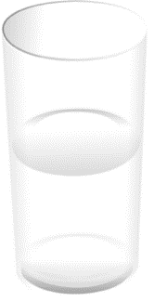Which of the following best describes what a compound is?

**A.** a fluid that conforms to the shape of its container

**B.** a pure substance made up of only one type of atom

**C.** a substance made up of two or more different types of atoms bonded together

**D.** a combination of two or more elements that are not chemically bonded

**Question 8**

Which of the following is the best example of a physical change?

**A.** ice turning into water

**B.** wood burning to form a black ash

**C.** baking soda in vinegar producing gas bubbles

**D.** caramelisation of sugar

**Question 9**

Which of the following is a physical property?

**A.** elasticity

**B.** reactivity

**C.** toxicity

**D.** flammability

**Question 10**

Which of the following best describes a proton?

**A.** a positively charged subatomic particle found in the nucleus of an atom

**B.** a radioactive particle

**C.** a positively charged ion

**D.** a negatively charged subatomic particle that moves around the nucleus of an atom

**E.** an uncharged subatomic particle found in the nucleus of an atom

**Question 11**

Atoms are basic units and the building blocks of matter.

What is the nucleus of an atom made up of?

**A.** protons and electrons

**B.** neutrons and electrons

**C.** protons and neutrons

**D.** neutrons, protons, and electrons

**E.** protons only

**Question 12**

What is the electric charge of an electron?

**A.** positive

**B.** negative

**C.** neutral

**D.** none of the above

**E.** all of the above

**Question 13**

Which of the following best shows that a chemical change has taken place?

**A.** solid turning to liquid

**B.** change in shape

**C.** bubbles forming

**D.** change in size

**Question 14**

What are the substances present at the start of a chemical reaction called?

**A.** products

**B.** catalysts

**C.** precipitates

**D.** reactants

**E.** ingredients

**Question 15**

Which of the following must be present for a combustion reaction to occur?

**A.** hydrocarbon

**B.** carbon monoxide

**C.** water

**D.** carbon dioxide

**E.** oxygen

**Short Answer Section**

**Question 1**

(a) complete the following diagram (a, b, c, d) that compares the difference between pure substances and mixtures (5 marks)

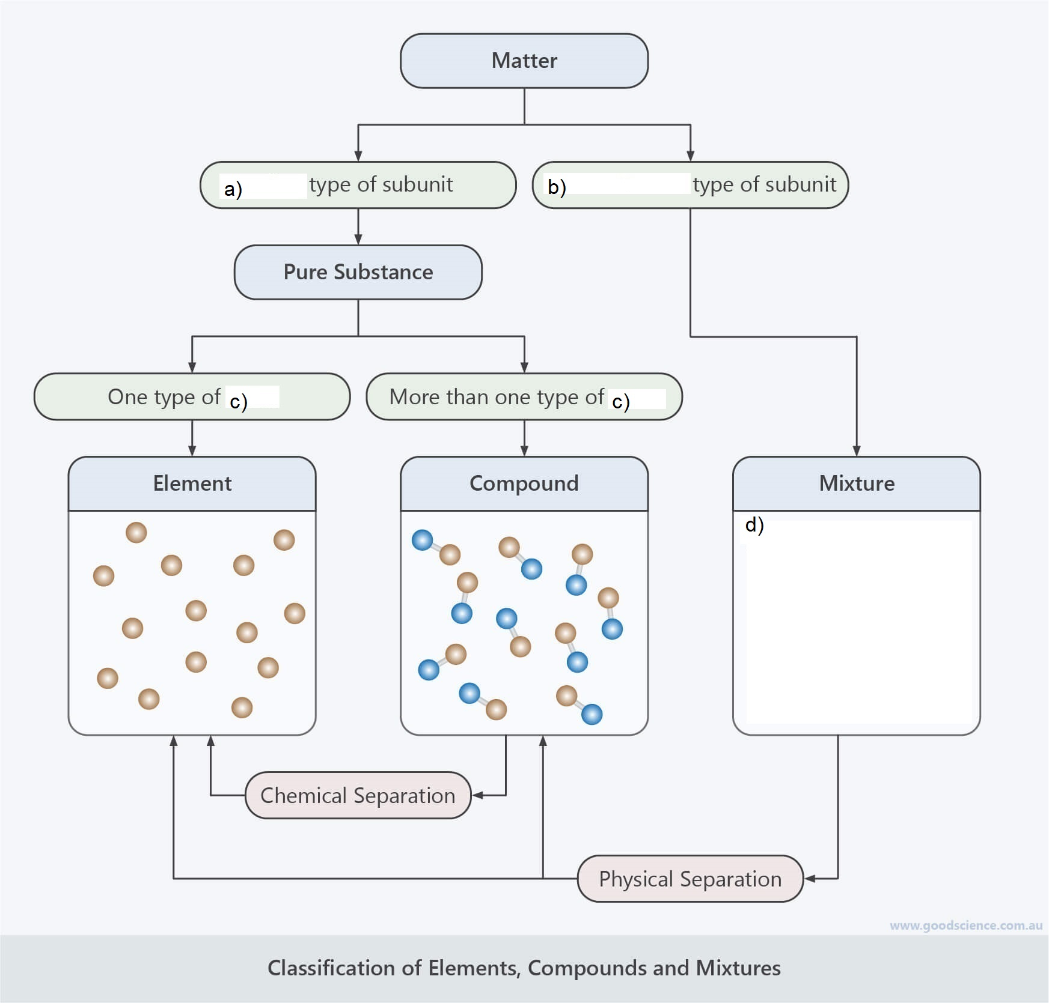

(b) Identify each of the following as a pure substance or a mixture by ticking the appropriate cell. (5 marks)

|  |  |  |
| --- | --- | --- |
| Substance | *Pure* | *Mixture* |
| Cake |  |  |
| Sugar |  |  |
| Diamond |  |  |
| Vegetable soup |  |  |
| Aluminium |  |  |

**Question 2**

Most matter on Earth exists in three different states: solid, liquid and gas.

(a) Draw lines to match each state of matter to the best description. (3 marks)

|  |  |  |
| --- | --- | --- |
| ***State of Matter*** |  | ***Description*** |
| Solid |  | Takes up a fixed amount of space, but its shape changes to match its container |
| Liquid |  | Takes up all available space,  but can be compressed |
| Gas |  | Has a definitive shape  that cannot be changed easily |

**Question 3** (4 marks)

Are changes of state an example of a physical change or a chemical change?

Explain your answer using your knowledge of the particle model and chemical bonding.

_____________________________________________________________________________________________

_____________________________________________________________________________________________

_____________________________________________________________________________________________

_____________________________________________________________________________________________

_____________________________________________________________________________________________

_____________________________________________________________________________________________

_____________________________________________________________________________________________

_____________________________________________________________________________________________

**Question 4**

You find an unknown substance in your backyard that you suspect may be made of pure metal.

List 3 common properties shared by metals that you could use to check. (3 marks)

i) ____________________________________________________________________________

ii) ____________________________________________________________________________

iii) ____________________________________________________________________________

**Question 5** (5 marks)

Luke left an iron frying pan outside. After the pan was exposed to a few weeks of heavy rain, Luke noticed that the pan’s surface had become covered with an orange-red flaky substance.

(a) What is this orange-red flaky substance commonly called? (1 mark)

_____________________________________________________________________________________________

_____________________________________________________________________________________________

A chemical reaction between iron from the frying pan and oxygen from the air took place to form the substance

(i) Identify the reactant(s) in this chemical reaction. (1 mark)

_____________________________________________________________________

(ii) What is the definition of a product in a chemical reaction? (2 mark)

_____________________________________________________________________

**Question 6**

Australian society relies on burning fuels to produce heat and electricity.

An incomplete word equation representing fuel burning in an unlimited supply of oxygen is shown below.

fuel + oxygen  ________________ + ___________

(a) Complete the equation above using appropriate words. (2 marks)

(b) What is the type of chemical reaction represented by the above word equation? (1 mark)

_____________________________________________________________________________

**Question 7**

Chemical reactions can either be endothermic or exothermic. With the help of the following diagram, explain the difference between the two types of reactions. (4 marks)













